Ex.No:7B | DATA VISUALIZATION USING TABLEAU
Date:

AIM:
To perform data analysis and visualization on the Retail Sales dataset using Tableau Desktop by creating bar charts, line charts, pie charts, dashboards, and stories to analyze product category sales, regional sales, monthly sales trends, top-performing products, quantity sold, and sales distribution.
ALGORITHM:

- Data Ingestion & Connection
Connect Tableau Desktop to the Retail Sales dataset as an Excel file.
- Verify the field data types such as OrderID, OrderDate, CustomerName, Product, Category, Region, Quantity, UnitPrice, and Discount.
- Data Preparation & Transformation
Check the dataset for missing or null values and ensure that the required fields are correctly recognized by Tableau.
- Create a calculated field Sales using the formula:
[Quantity] × [UnitPrice] × (1 − [Discount])
- Exploratory Visual Analysis
- Sales by Product Category: Create a bar chart to visualize the total sales for each product category.
- Sales by Region: Create a bar chart to compare total sales across different regions.
- Monthly Sales Trend: Create a line chart using OrderDate and Sales to analyze monthly sales trends.
- Top Products by Sales: Create a bar chart to identify the products with the highest sales.
- Quantity Sold by Category: Create a bar chart to visualize the quantity of products sold in each category.
- Sales Distribution by Category: Create a pie chart to represent the distribution of total sales across product categories.
12. Dashboard & Story Creation
Combine the created worksheets into an interactive Dashboard.
OUTPUT:

Bar Chart Creation:
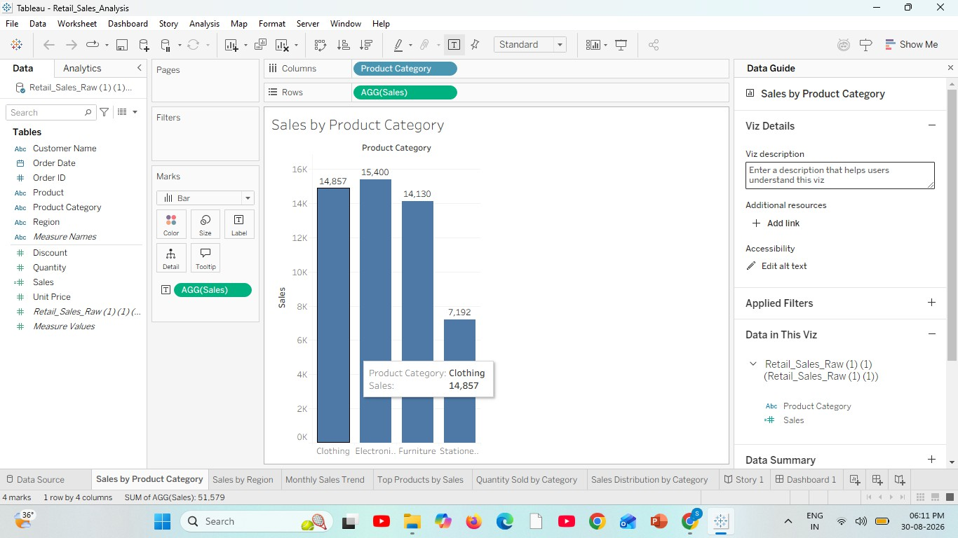
Sales by Product Category

Sales by Region

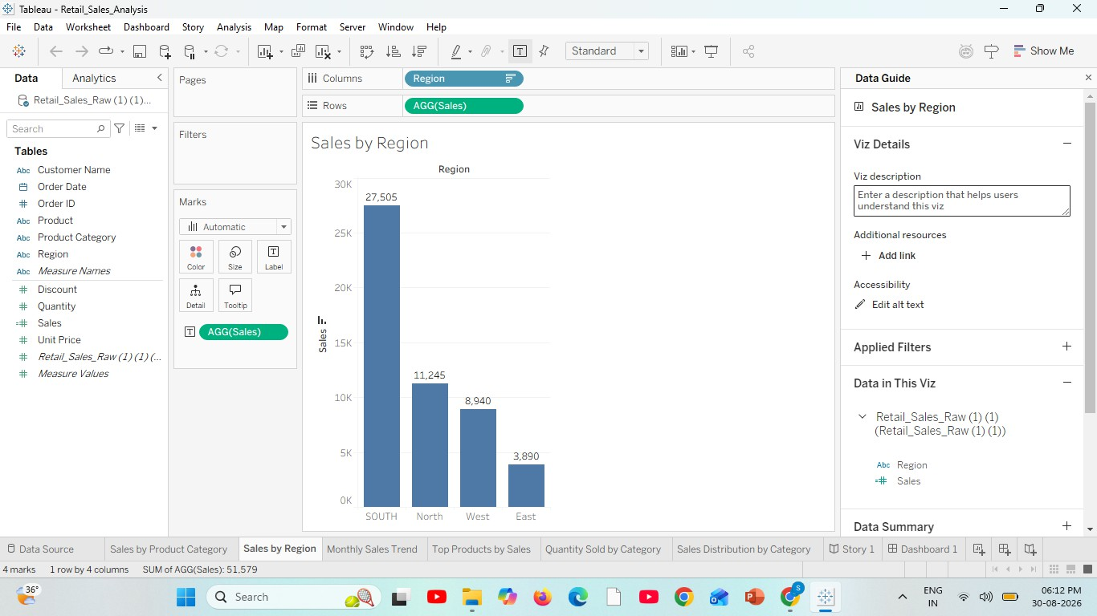

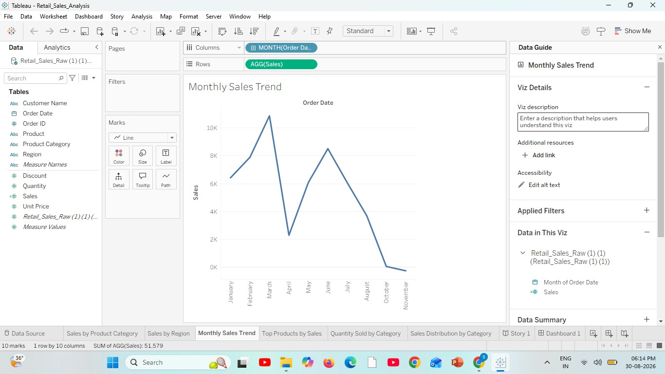
Line Chart Creation: Monthly Sales Trend:

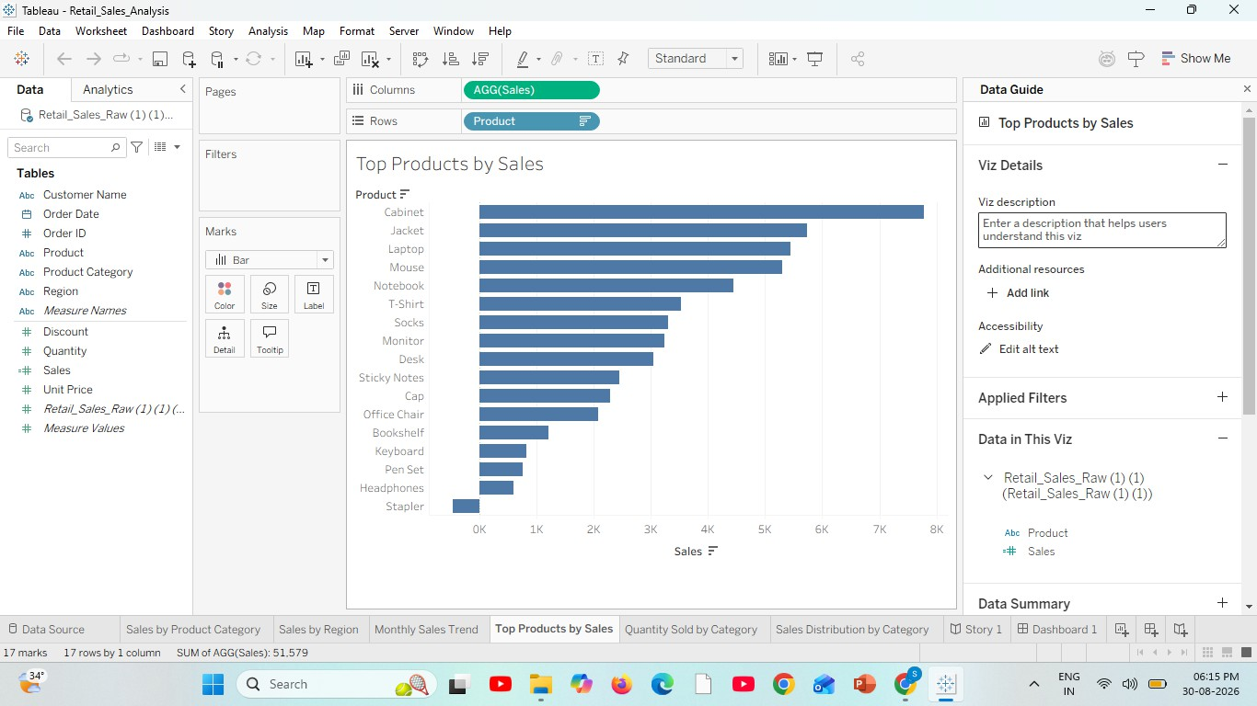
Top Products by Sales:

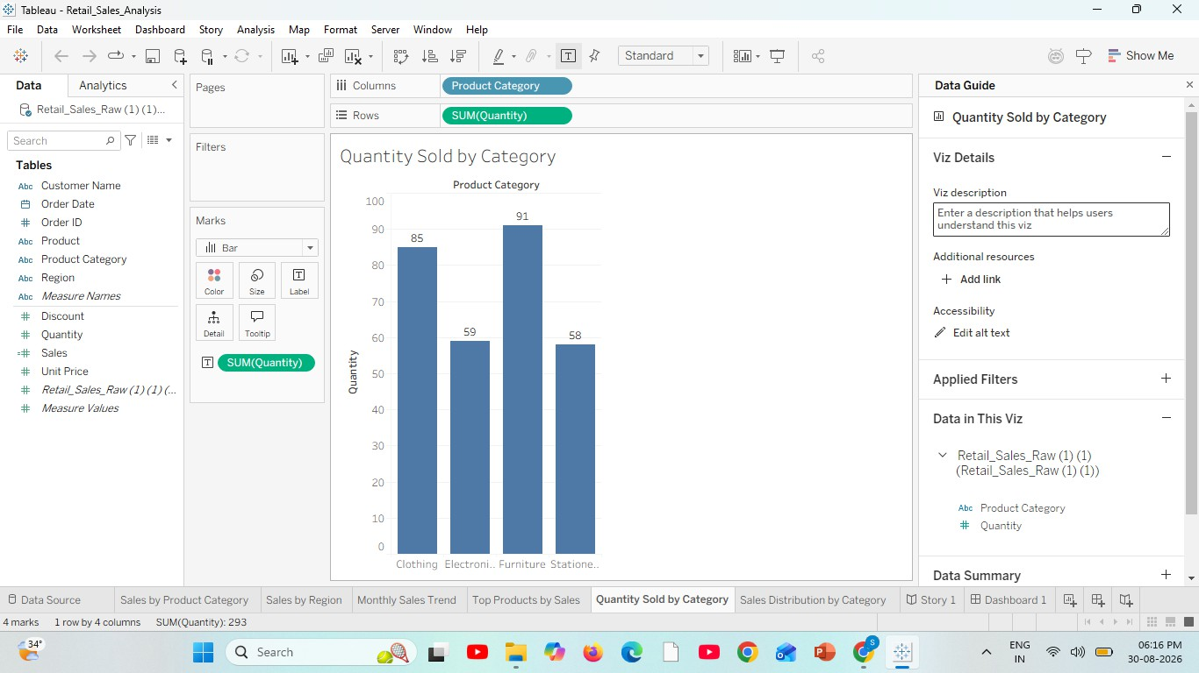
Quantity Sold by Category:

Pie Chart Creation:
Sales Distribution by Category:

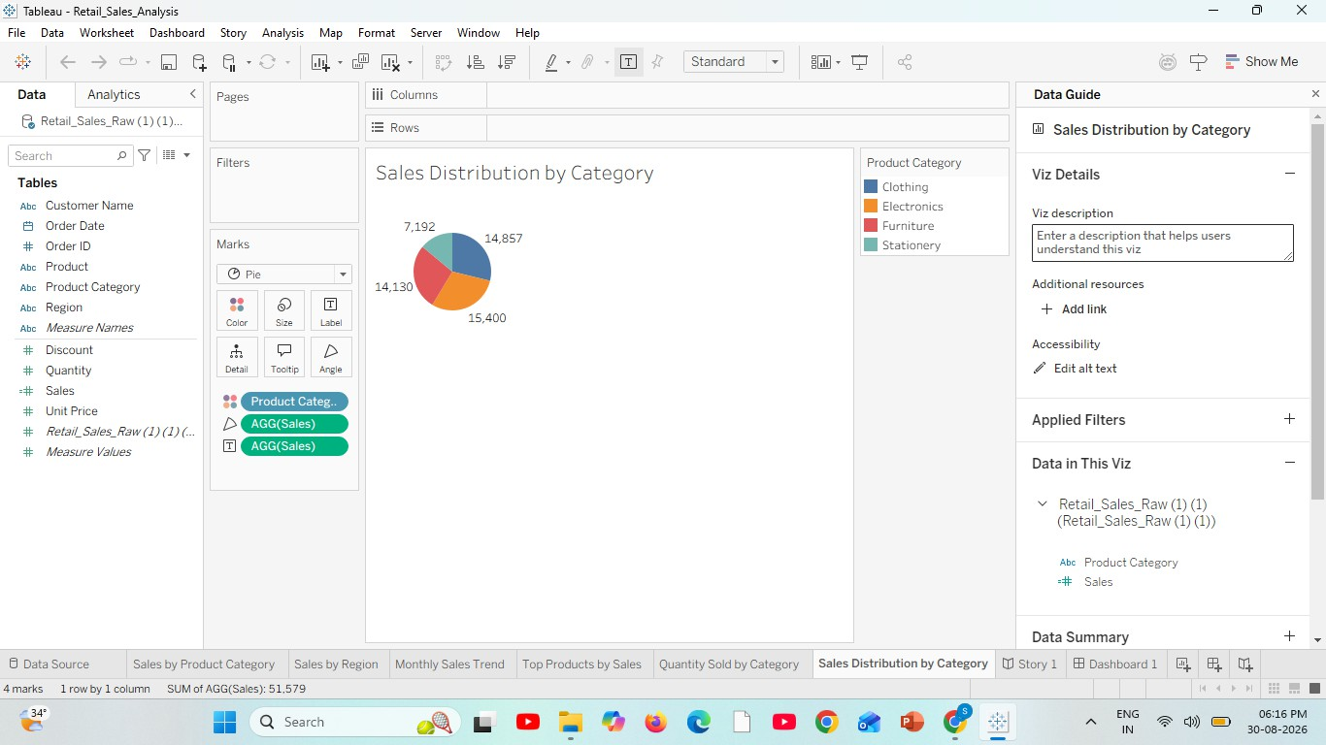

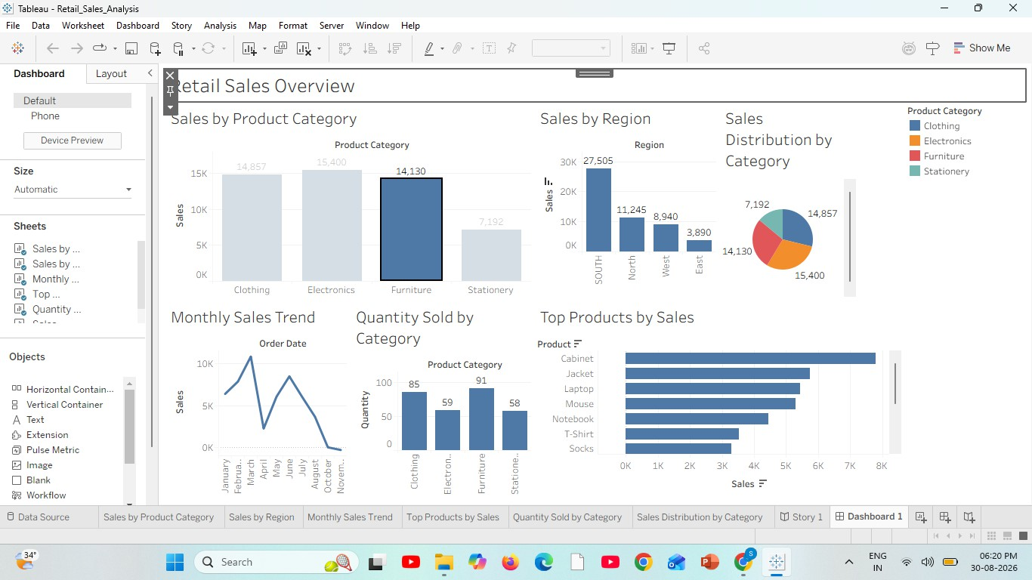
Dashboard Creation:

Story Creation:
Story Point 1
Sales by Product Category

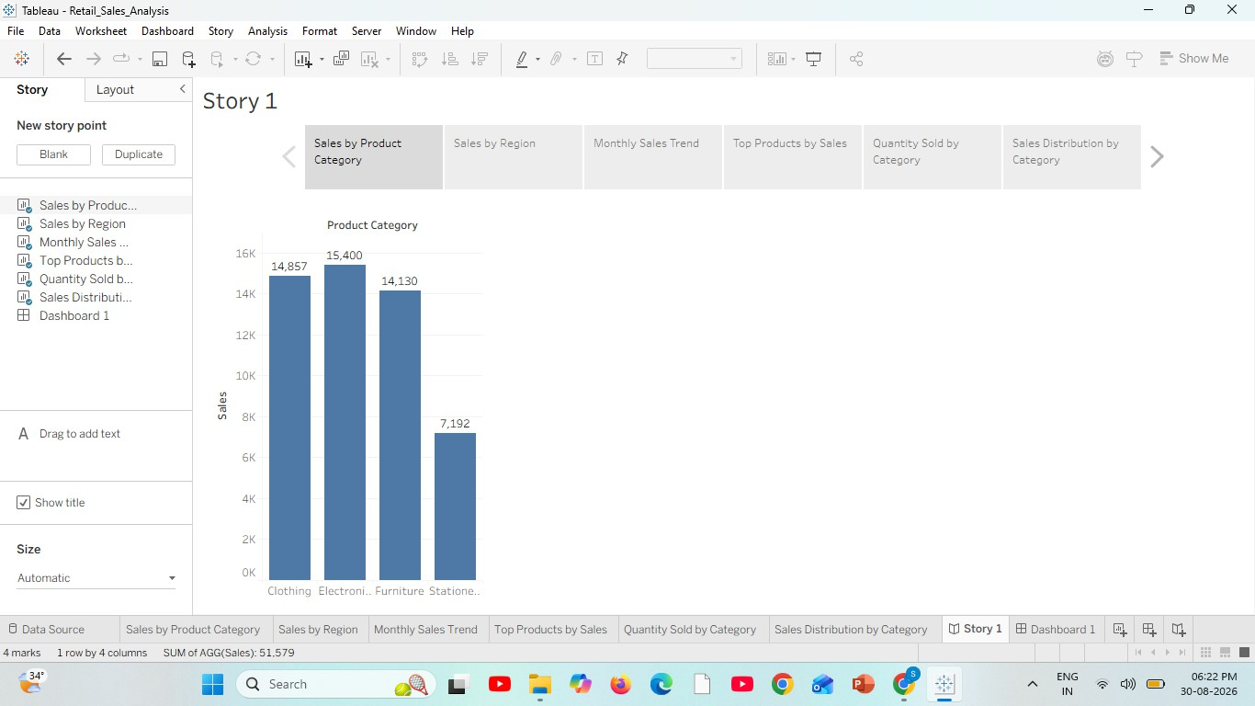

Story Point 2
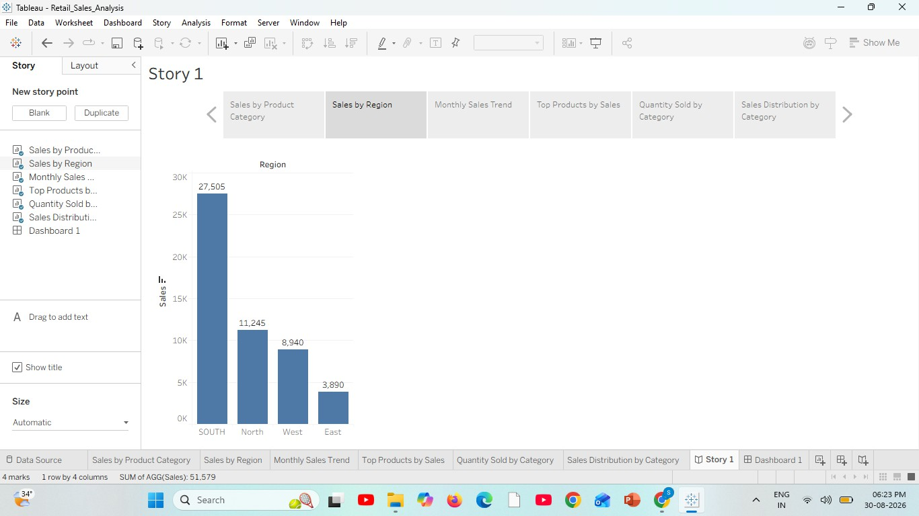
Sales by Region

Story Point 3
Monthly Sales Trend:

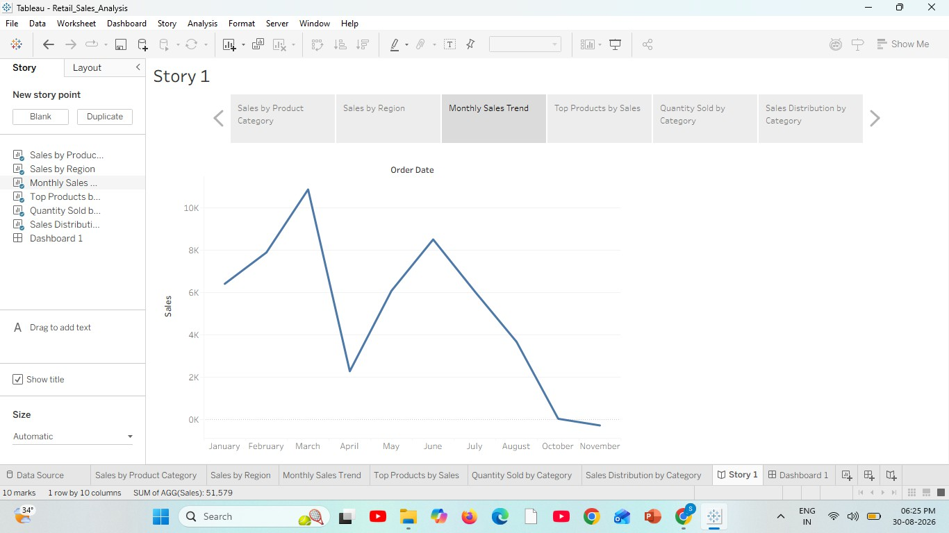

Story Point 4
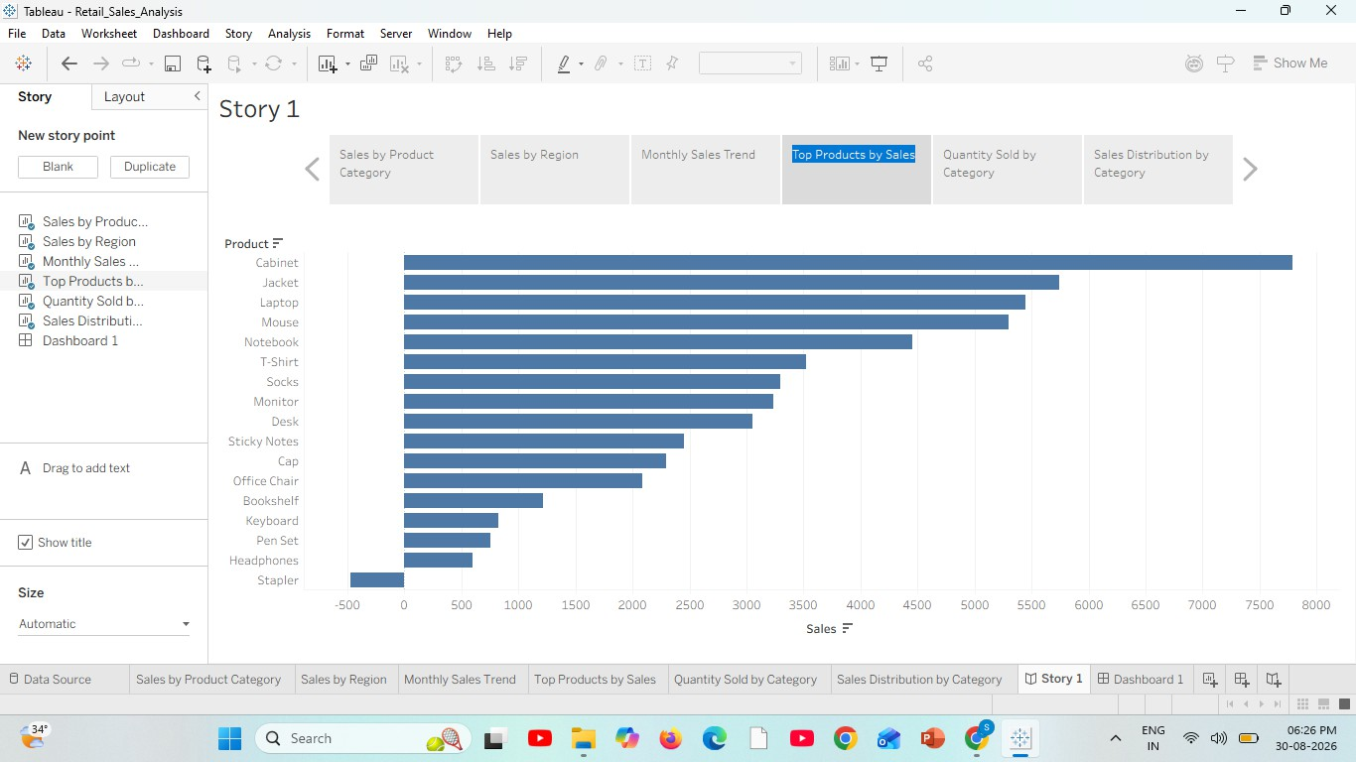
Top Products by Sales

Story Point 5
Quantity Sold by Category:

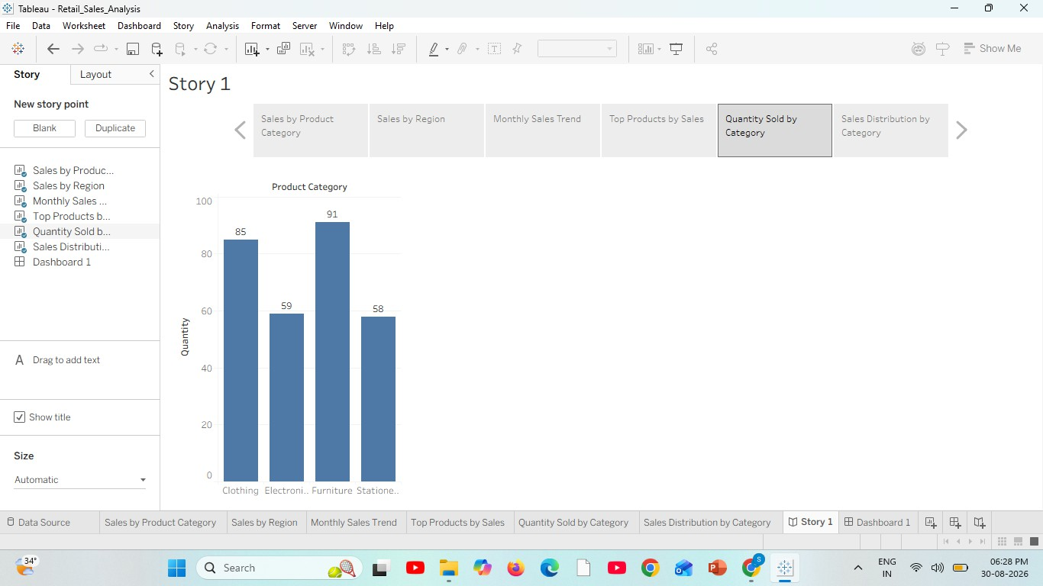

Story Point 4
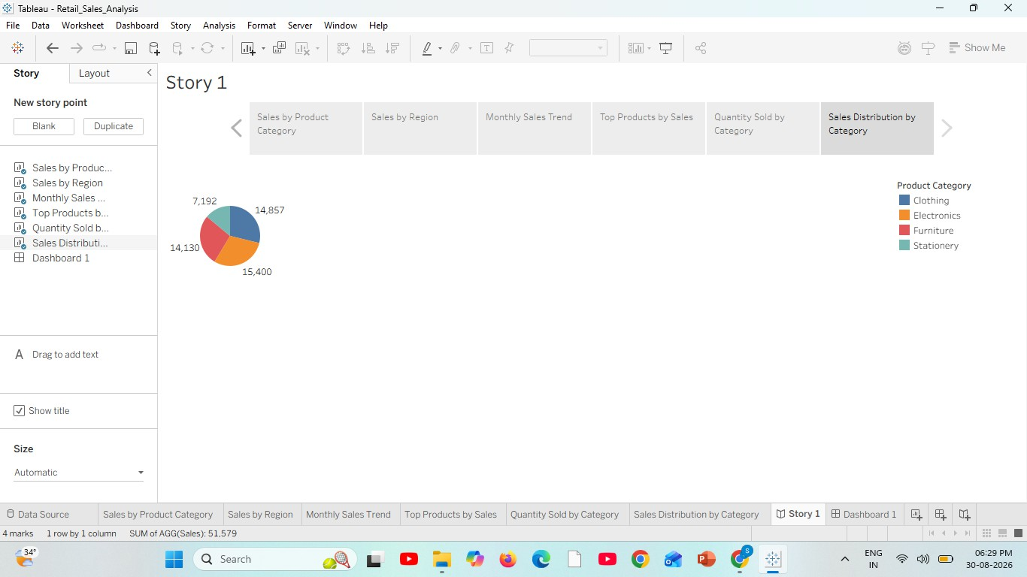
Sales Distribution by Category

RESULT:

